学习目标：掌握核心句型:Talk quietly. Keep your desk clean.

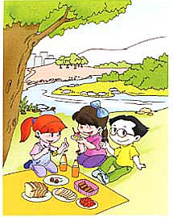
- 根据图意，写出最合适的问答句。（10分）
- What are they doing?
__________________________________________
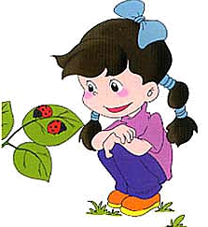
2. Is Chen Jie watching insects now?
__________________________________________
3. What’s your favourite colour? (按实际情况回答)
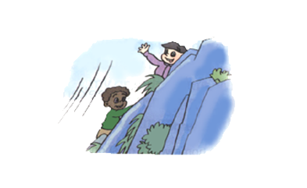
__________________________________________
4. What is Zhang Peng doing?
__________________________________________
5. Which month do you like best? (按实际情况回答)
__________________________________________
- 阅读理解（10分）
It’s a nice day. We are having a good time. We are going on a field trip. Listen! The birds are singing. Look! My father is doing an experiment. My mother is catching butterflies. My grandparents are playing chess. My brother is running on the grass. What am I doing then? I am taking pictures.
( )1. My grandma is playing chess.
( )2. My brother is running.
( )3. My sister is catching butterflies.
( )4. I am taking pictures.
( )5. The birds are flying.

